**ABOUT THE DATASET**

The Titanic dataset gives insight into the Titanic shipwreck and the survival rate of passengers with respect to Pclass, Sex, Age, Fare, Embarkation port and family. This dataset comprises 1309 data points (rows) and 13 informative columns, namely; ‘PassengerId’, ‘Survived’, ‘Pclass’, ‘Name’, ‘Sex’, ‘Age’, ‘SibSp’, ‘Parch’, ‘Ticket’, ‘Fare’, ‘Cabin’, ‘Embarked’ and ‘Family’.

In this analysis, ‘PassengerId’ and ‘Ticket’ are dropped because they are not necessary for the analysis. Also, ‘Cabin’ is dropped because it contains too many null values. In the Embarked column, S stands for Southampton, C stands for Cherbourg and Q stands for Queenstown.

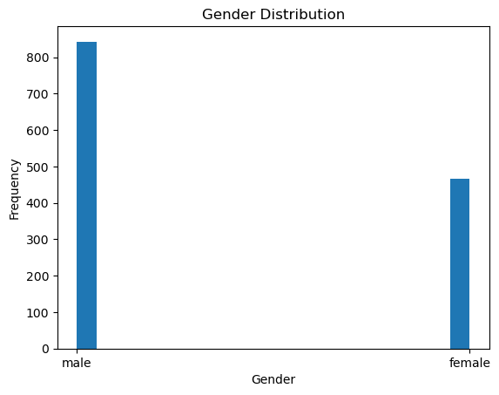

**For Gender Distribution:** The bar chart above shows that they were 843 males and 466 females. This indicates that males who boarded the ship were more than females.

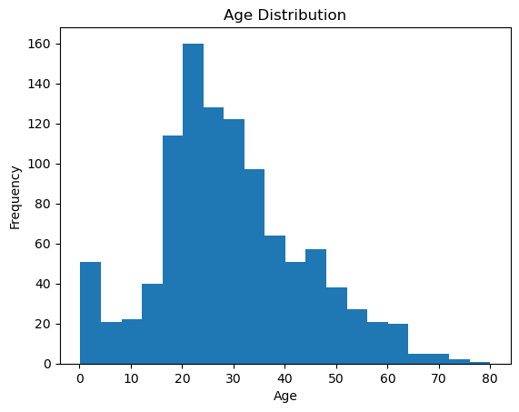

**For Age Distribution:** In the chart above, Age of passengers range from 1 to 80 years, with high frequency at 20 t0 30 years. This shows that most of the passengers were young people.

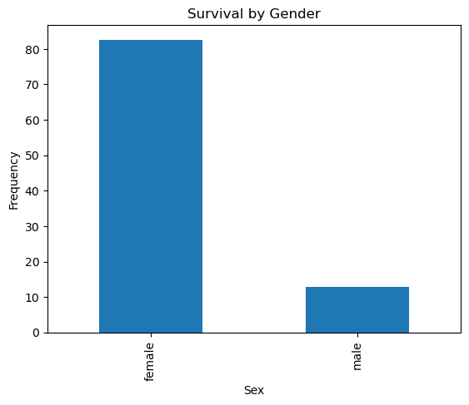

**For Survival by Gender:** In the chart above, 82% of females survived and 12% of the males survived in. This shows that more females survived.

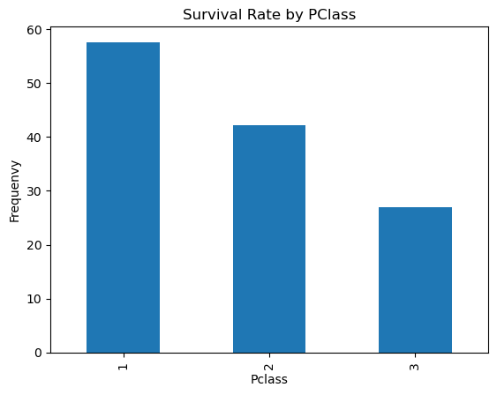

**For Survival rate by Pclass:** In the chart above, 57% of people survived in first class, 42% of people survived in second class and 26% of people survived in third class. It shows that more people in first class survived.

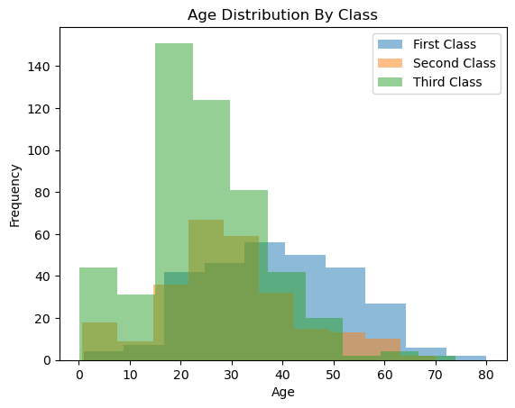

**For Age Distribution by Class:** The chart shows that for first class, age range of passengers is from 2 to 80 and it has a normal distribution. For second class, age range from 2 to 70 years and for third class, age range from 1 to 74 years.

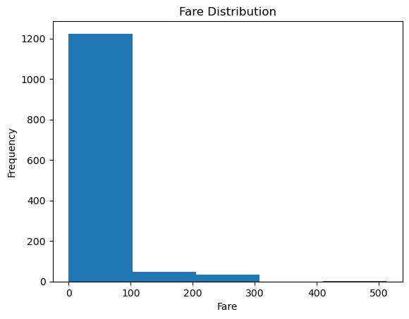

**For Fare Distribution:** The chart shows that the fare of passengers ranged from 0 to 512 naira with the highest frequency from 0 to 100 naira. This shows that large number of the passengers paid lesser amount.

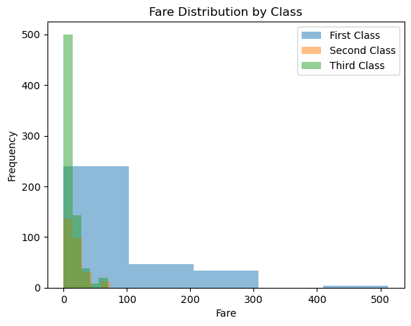

**For Age Distribution by Class:** The chart shows that people in first class paid 0 to 512 naira, people in second class paid 0 to 75 naira and third class people paid 0 to 72 naira. This means that people in first class paid more fare.

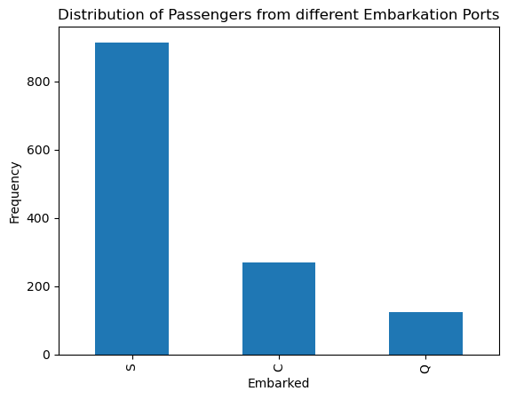

**For Distribution of Passengers from Different Embarkation Ports:** The chart shows that 914 passengers embarked at Southampton, 270 passengers embarked at Cherbourg and 123 passengers embarked at Queenstown. This means that more passengers embarked at Southampton.

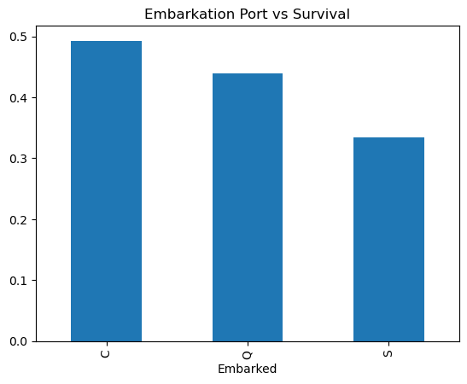

**For Embarkation Port vs Survival:** The chart shows that there is 0.492593 correlation between those that embarked at Cherbourg and survival, there is 0.439024 correlation between those that embarked at Queenstown and survival and there is 0.333698 correlation between those that embarked at Southampton and survival. All the Embarkation ports have positive correlation with survival, however, Cherbourg has more positive correlation with survival.

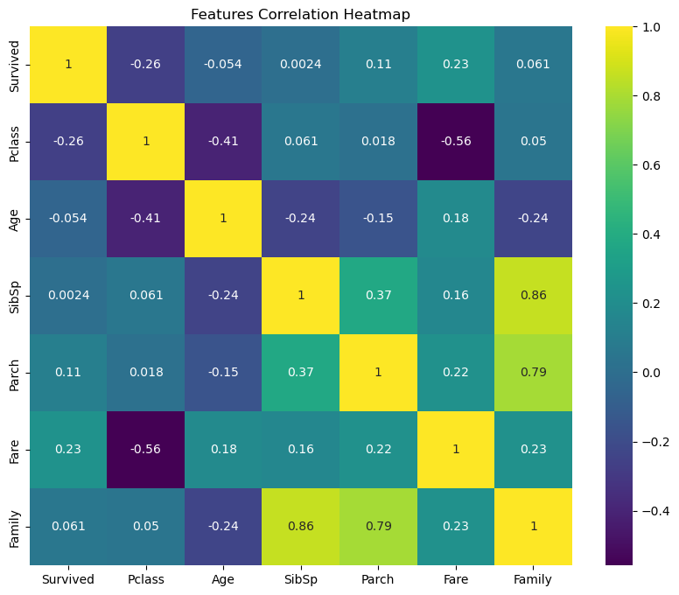

**For Features Correlation Heatmap:** The chart above shows that there is negative correlation (-0.26) between Pclass and Survival, there is positive correlation (0.061) between Family and Survival, there is negative correlation (-0.054) between Age and Survival, there is positive correlation (0.23) between Fare and Survival, there is negative correlation (-0.41) between Pclass and Age, there is negative correlation (-0.56) betweeen Pclass and Fare, there is positive correlation (0.05) between Pclass and Family, there is positive correlation (0.18) between Age and Fare, and there is positive correlation (0.23) between Family and Fare.

**SUMMARY**

In summary, this dataset gives insights into the impact of Pclass, Sex, Age, Fare and Embarkation port on the survival rate of passengers on the ship. It shows that older people used first class and they paid more fare and they also survived more. It also shows that females survived more than the males. The above outcome could be because the older people earn more salary which made them use first class and also because the older people and females were given preference during the rescue mission.

These findings can guide potential sea travelers on the class to use when travelling and also educate rescue teams on the need for sufficient life boats to take along for rescue missions so that some people are not given preferential treatments while others are left to die.